**CS304 Assignment # 1 Fall 2021**

**Name**: Abdul Rehman.

**VU ID**: BC200403287.

**Problem Statement:**

Due to the increasing number of complaints regarding meat quality, Govt. Of Pakistan has decided to launch an "online meat Store" named "Meat On Wheels" so that, people can

purchase red and white meat from home. Through this way, Govt. of Pakistan not only can ensure the quality of meat but also people can be satisfied with the fact that the meat they are purchasing is healthy and Halal.

The “Meat On Wheels” store will offer both (red and white) types of meat with all different categories or portions. The user will be shown a list of Meat Products, which can be selected or deselected from the provided list. The user will need to get registered to buy Meat Products. At the end of shopping, the customer can double-check all the Products added into his Cart and verify the total amount before payment. The Store Administrator will manage Meat categories and Products and assign orders to Delivery Boys.

Draw an Object Model (Class Diagram) for the given scenario showing main objects, their attributes, functions and relationships.

**Step by Step Guidance:**

* Extract the main objects (entities) of above system.
* Find the necessary attributes and functions that need to be associated with each object.
* Identify the relationships among identified objects.

**Solution:**

MS Visio File of “**Meat on Wheels**” online shop Project:



**Complete Image** of “**Meat on Wheels**” online shop Project: **( MS Visio File given at Start )**

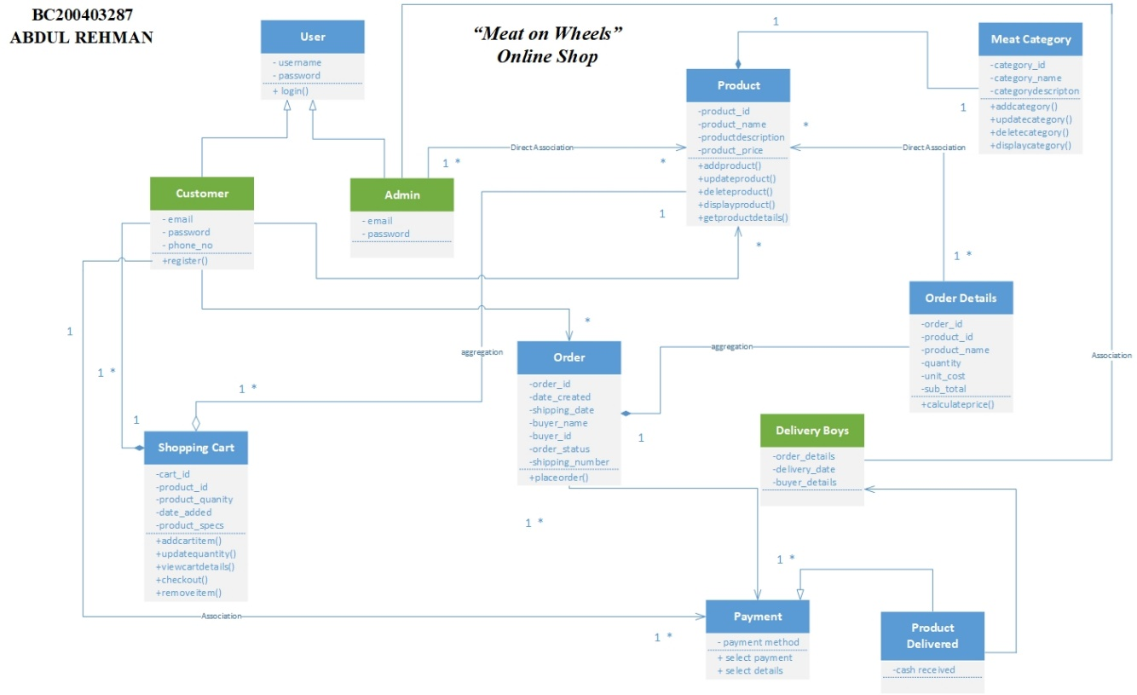

**Image parts** of “**Meat on Wheels**” online shop Project: **( MS Visio File given at Start )**

1. **Upper Left Side** of ‘**Meat on Wheels’** image of my project:

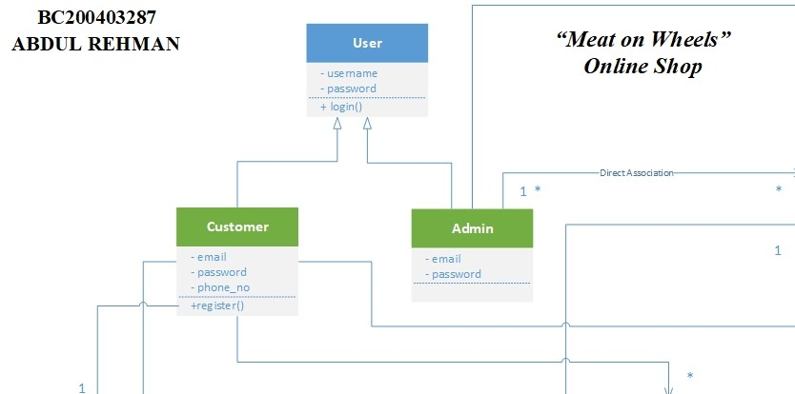

1. **Bottom Left Side** of ‘**Meat on Wheels’** image of my project:

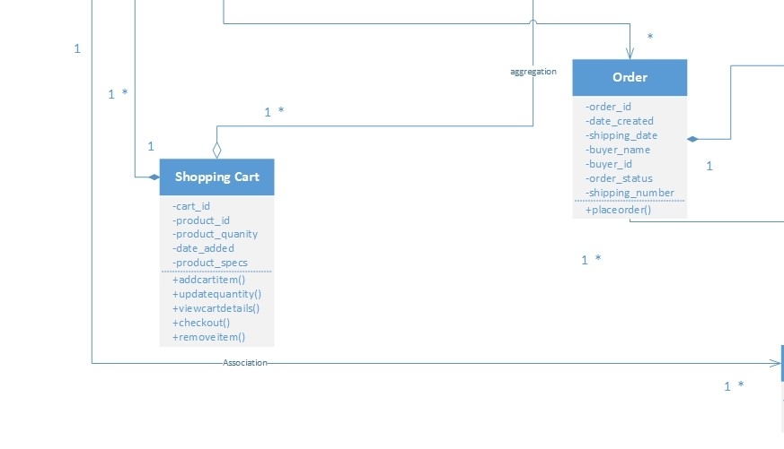

1. **Upper Right Side** of ‘**Meat on Wheels’** image of my project:

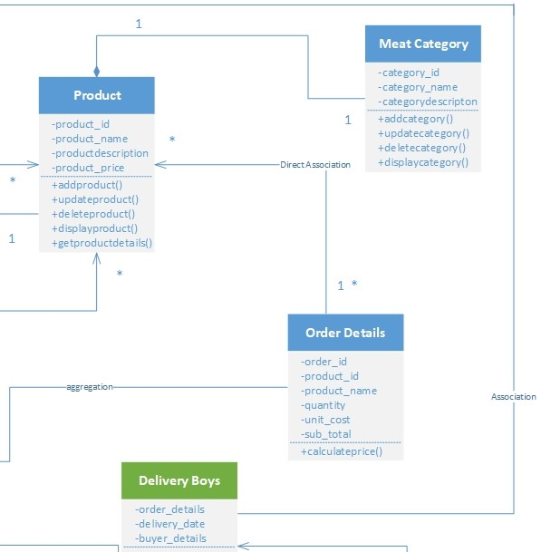

1. **Lower Right Side** of ‘**Meat on Wheels’** image of my project:

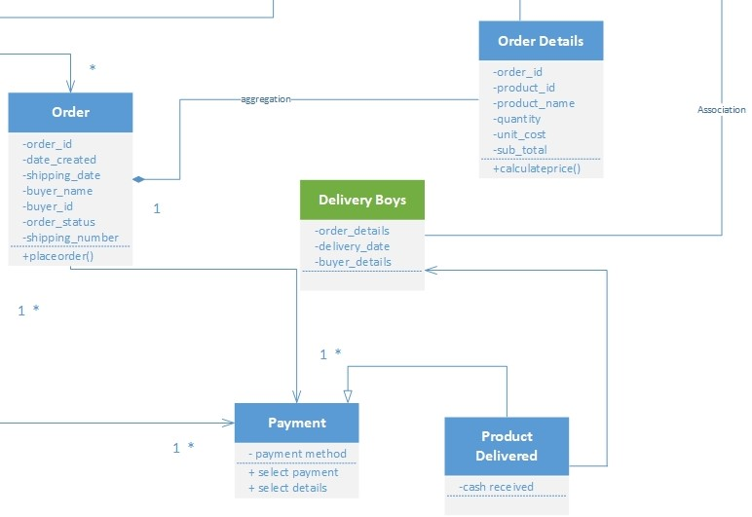

* ***‘Selected all’*** *image* of my Project “**Meat on Wheels**”: **( MS Visio File given at Start )**

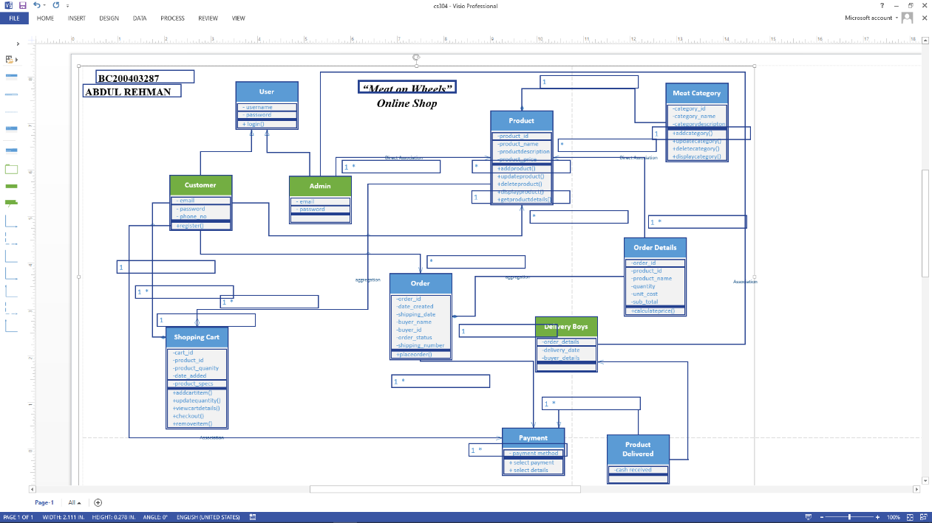

1. **Top Left Side** of ‘**selected all’** image of my project:

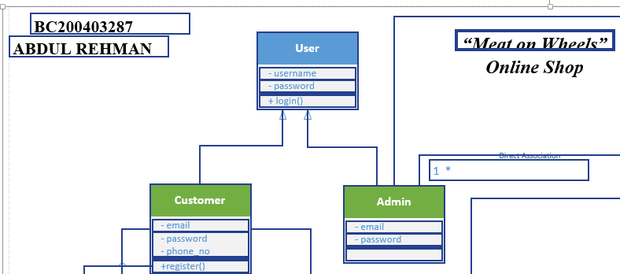

1. **Top Right Side** of ‘**selected all’** image of my project:

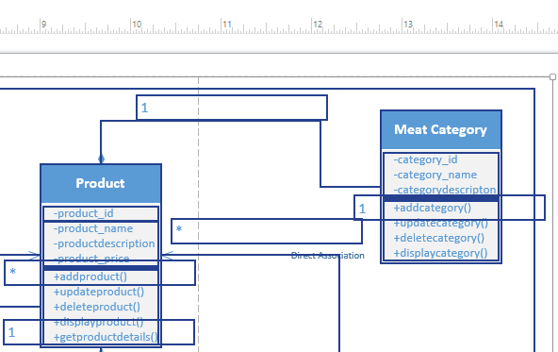

1. **Bottom Left Side** of ‘**selected all’** image of my project:

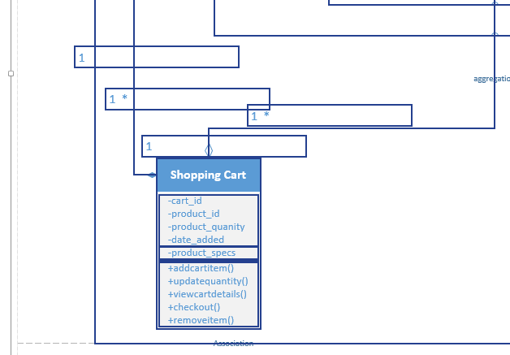

1. **Bottom Right Side** of ‘**selected all’** image of my project:

